Cloud Architect, Cloud Developer, Cloud DevOps Engineer

Compute

**Lab Steps**

Task 1: Sign in to AWS Management Console

1. Click on the  button, and you will get redirected to AWS Console in a new browser tab.
2. On the AWS sign-in page,

* Leave the Account ID as default. Never edit/remove the 12 digit Account ID present in the AWS Console. otherwise, you cannot proceed with the lab.
* Now copy your **User Name** and **Password** in the Lab Console to the **IAM Username and Password** in AWS Console and click on the **Sign in** button

     3. Once Signed In to the AWS Management Console, Make the default AWS Region as **US East (N. Virginia) us-east-1.**

Task 2: Create a Security Group for Launch template

1. Make sure you are in the**N.Virginia**Region.
2. Navigate to**EC2** by clicking on the  menu available under the **Compute**section.
3. On the left panel menu, select the security group under the Network**& Security**section.
4. Click on the 
5. We are going to create a Security group for the Launch template with port 80 number enabled.
   * Security group name: Enter ***Launch-template-SG***
   * Description: Enter ***Security group for Launch template***
   * VPC: Select **Default VPC**

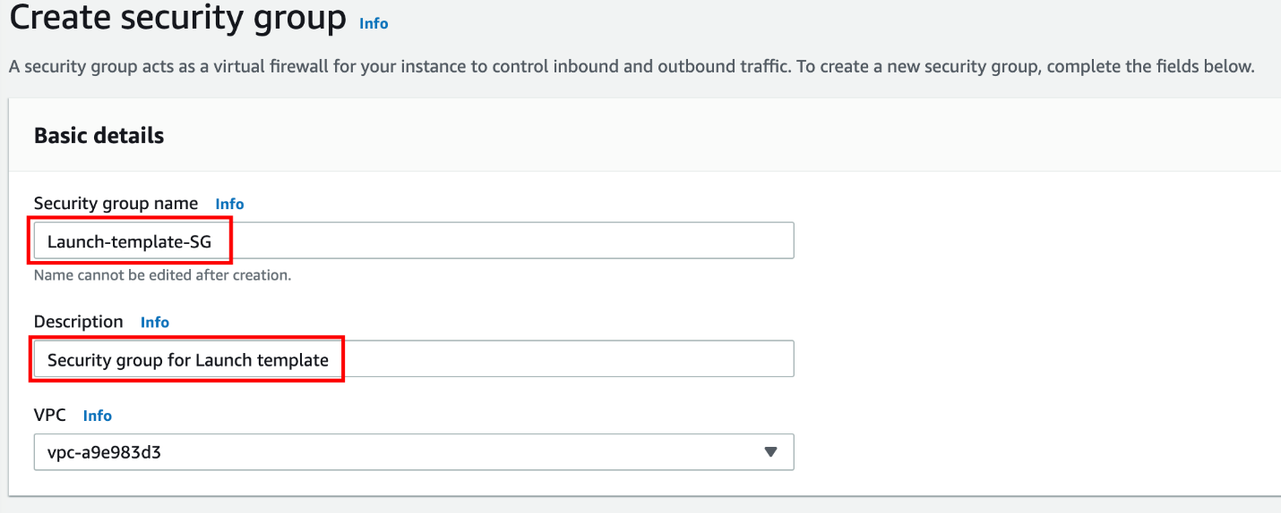

* Click on the   under **Inbound rules.**
  + Type : Select **HTTP**
  + Source : Select **Custom**
  + In the textbox add **0.0.0.0/0**

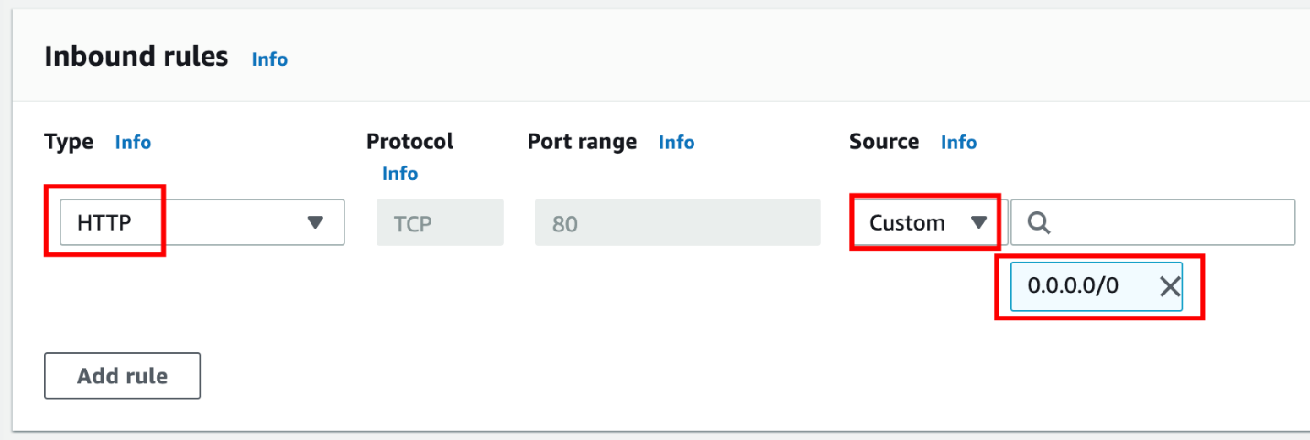

1. Leave everything as default and click on the 



Task 3: Create a Key pair for the Launch template

1. In the left navigation pane (scroll down) within **Network & Security**, click on the 
2. To create a new key pair, click on the  .
3. Fill in the details below:
   * Name: Enter ***WhizKeyPair***
   * File format: **pem (Linux & Mac Users)**or **ppk (Windows users)**
   * Leave other options as default.
   * Click on the
4. Key pair will be created.  
   

Task 4: Creating a Launch template

1. In the left navigation pane (scroll down) within **Instances**, click on the **Launch Templates**
2. Click on the 
3. Under **Launch template name and description** section:
   * Launch template name: Enter ***whizlabsLC***
   * Template version description: Type ***Launch template for whizdemo***
   * **Leave other options as default.  
     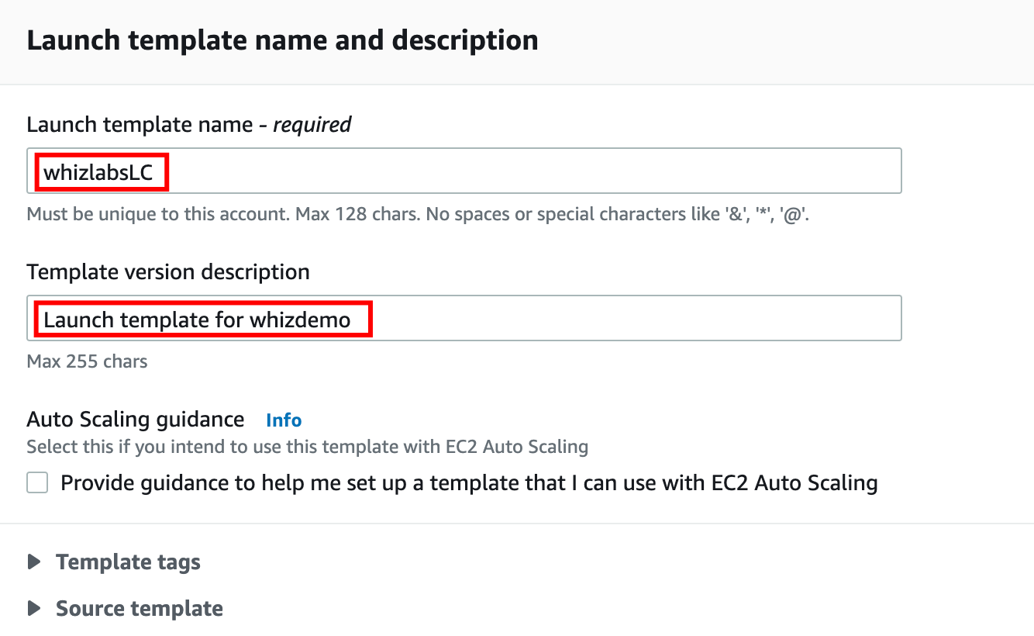**
4. Under Launch template contents:
   * Amazon machine image (AMI): Select **Amazon Linux 2 AMI (HVM), SSD Volume Type  
     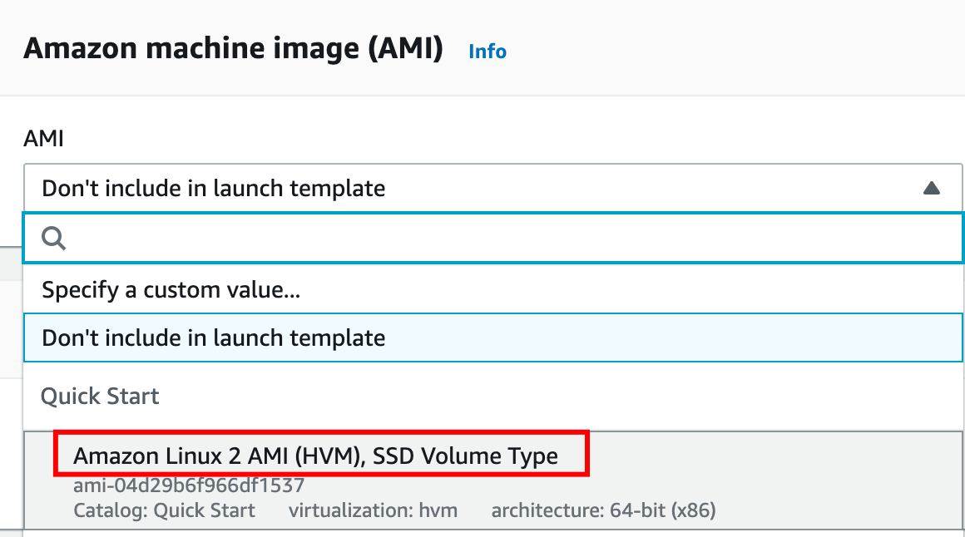**
   * Under Instance type:
     + Select **t2.micro** from the below list.

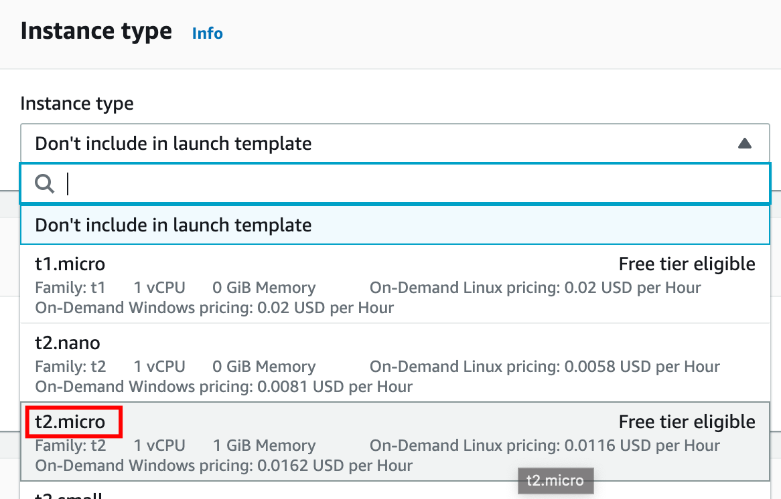

* Key pair (Login): Select **WhizKeyPair  
  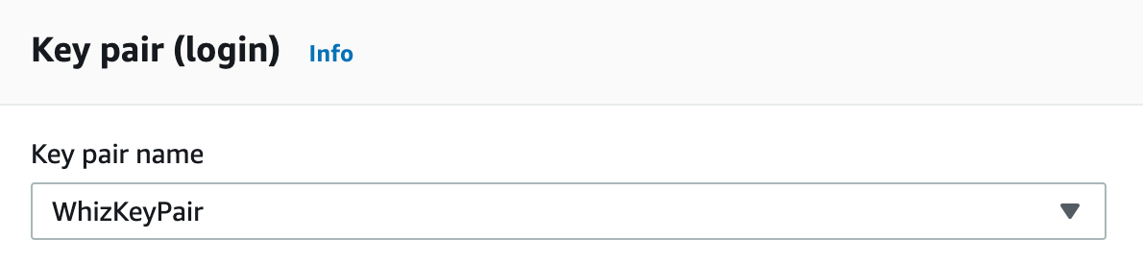**
* Networking settings:
  + Firewall(security groups): Select **Select existing security group**
  + Security groups: Select **Launch-template-SG** from the drop-down
  + Leave all other options as **default**.

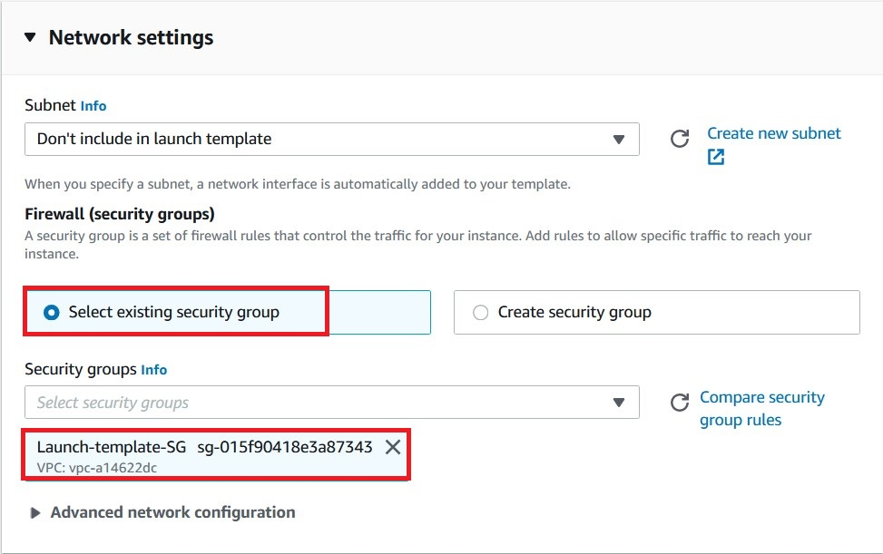

* Leave all other options as **default**.
* Expand the option of **Advance details**, Go to the **User data**at the bottom of the page and paste the below script.

|  |
| --- |
| #!/bin/bash  sudo su  yum update -y  yum install -y httpd  systemctl start httpd  systemctl enable httpd  echo "<html> <h1> Response coming from server </h1> </ html>" > /var/www/html/index.html |

* 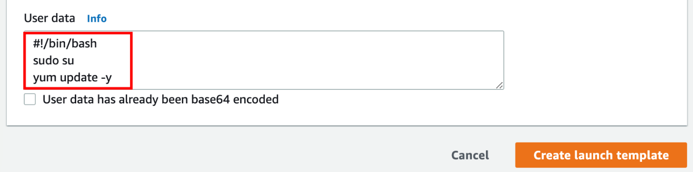

1. To create, click on the 

Upon successful creation, it will create a Launch template.  
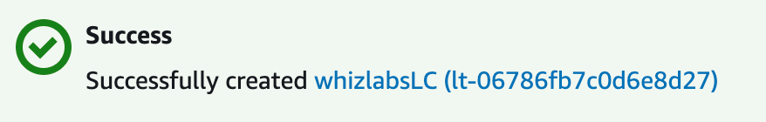

Task 5: Create an Auto Scaling Group

1. An Auto Scaling group is a scalable collection of EC2 instances. When you create an Auto Scaling group, you include information such as the subnets for the instances and the number of instances the group must maintain at all times.
2. Go to the left menu under EC2 and choose (underneath Launch Configurations) **.**
3. Click on the 
4. **Step 1 : Choose launch template or configuration**
   * Auto Scaling group name : Enter ***Whiz-ASG***
   * Select the Launch template **whizlabsLC**from the list and click on the    
     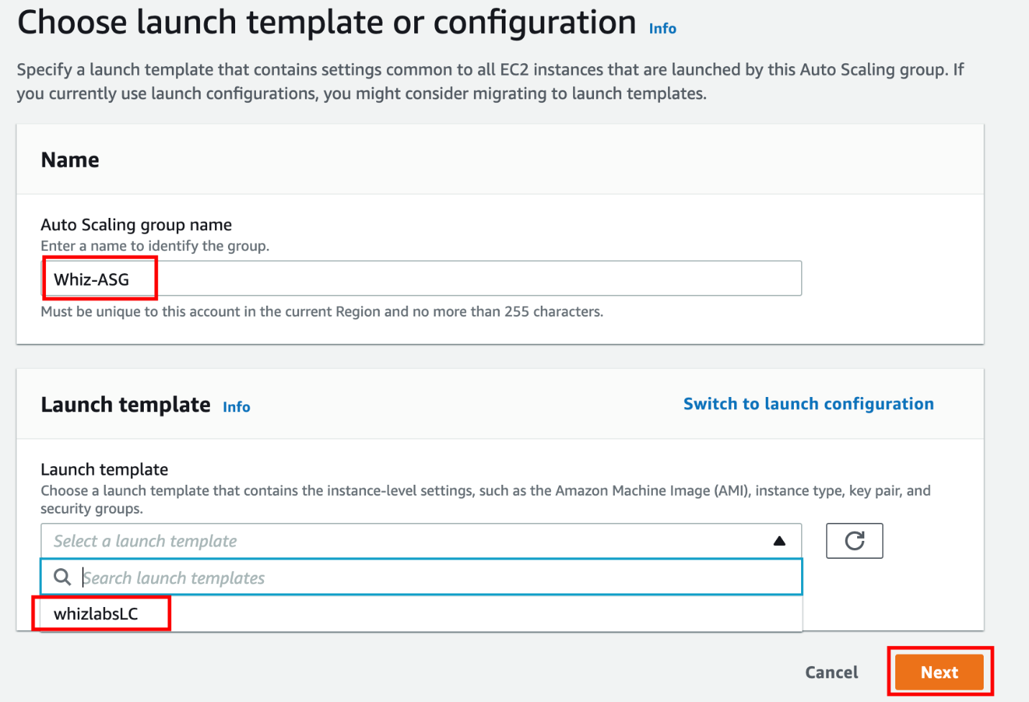
5. **Step 2: Configure settings**

* VPC: Select the **Default VPC** from the list.
* Subnet: Select atleast two subnets for your Auto Scaling instances.
* Click on the 

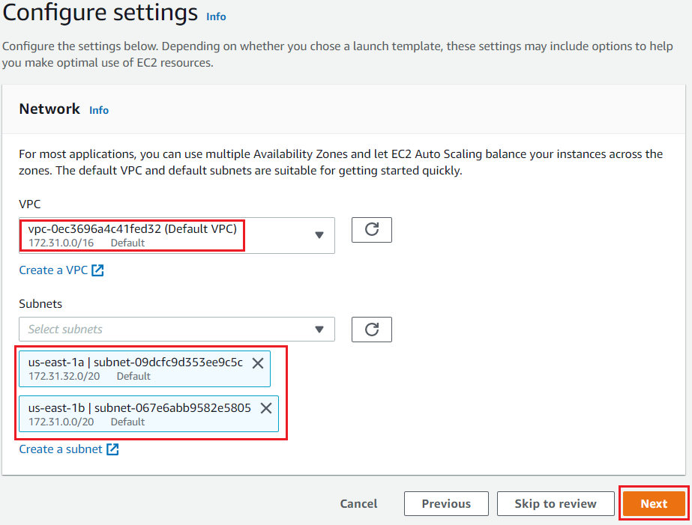

**6. Step 3: Configure advanced options**

* No changes needed in this page, click on the 

7. **Step 4: Configure group size and scaling policies**

* Under Group size - optional
* Desired capacity : Enter ***2***
* Minimum capacity : Enter ***2***
* Maximum capacity : Enter ***2***

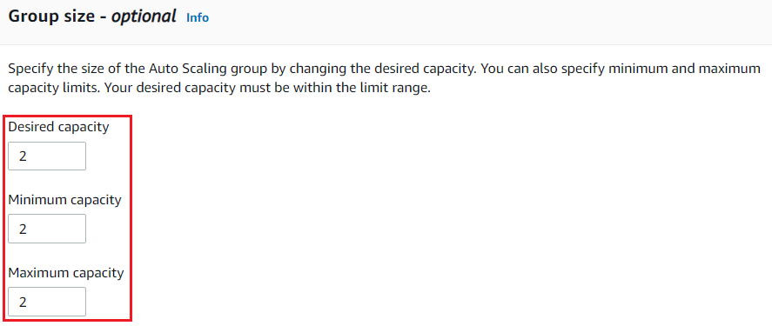

* Under Scaling policies - optional
  + Select **None**

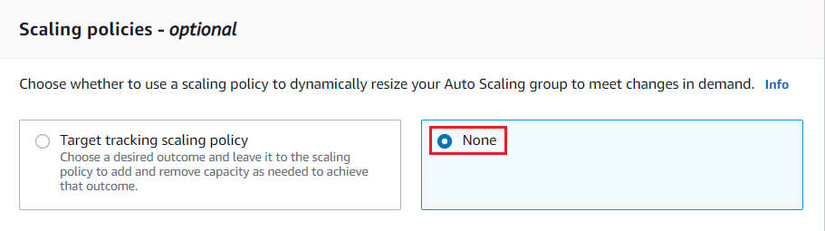

* Under Instance scale-in protection
  + No changes are needed, click on the 

1. **Step 5: Add notifications**
   * No changes are needed in this page, click on the 
2. **Step 6: Add tags**
   * Enter tags in key-value pairs to identify your auto scaling group **instances**.
     + Key : Enter **Name**
     + Value : Enter **Whiz**  
       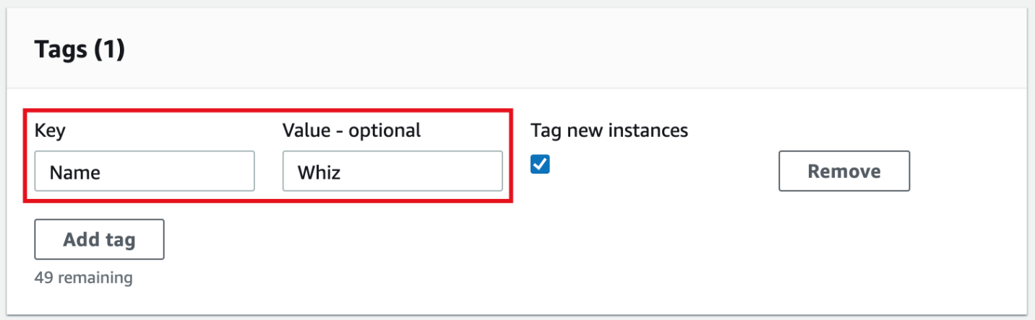
   * Click on the 
3. Now Review, scrolldown and click on the 
4. You will be redirected to the autoscaling group page, you will be able to see that two instances are launched by the autoscaling group.
   * 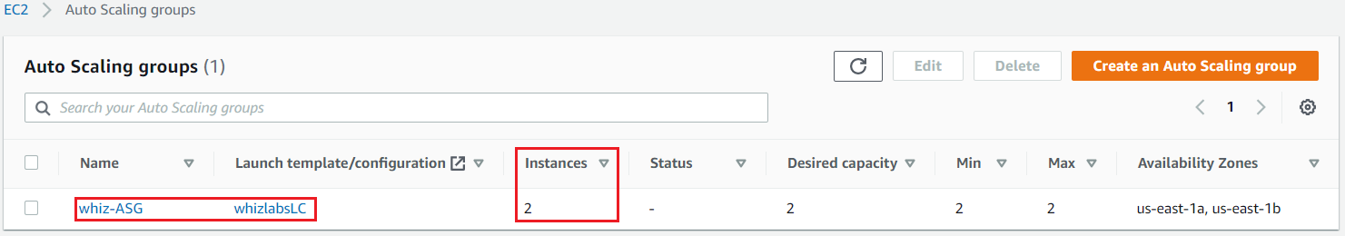
5. Now go to the EC2 instances list. You will see that there are **two new running instances** (which were created by your autoscaling group) You can confirm this from their tag name, which you gave at the time of creating the autoscaling group.
6. You have successfully created an autoscaling group with a policy to a minimum of 2 and a maximum of 2 instances.

Task 6: Test Auto Scaling Group

1. For testing the auto-scaling policy, go to the EC2 instance list and select one of your instances.
2. To terminate the EC2 instances manually:
   * Select one of the instances randomly
   * Click on the **Instance state**
   * Choose to terminate the instance by clicking on **Terminate instance.**  
     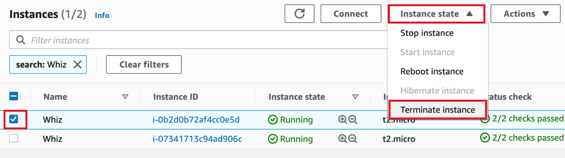
3. Confirm the termination by clicking on the Terminate button.  
   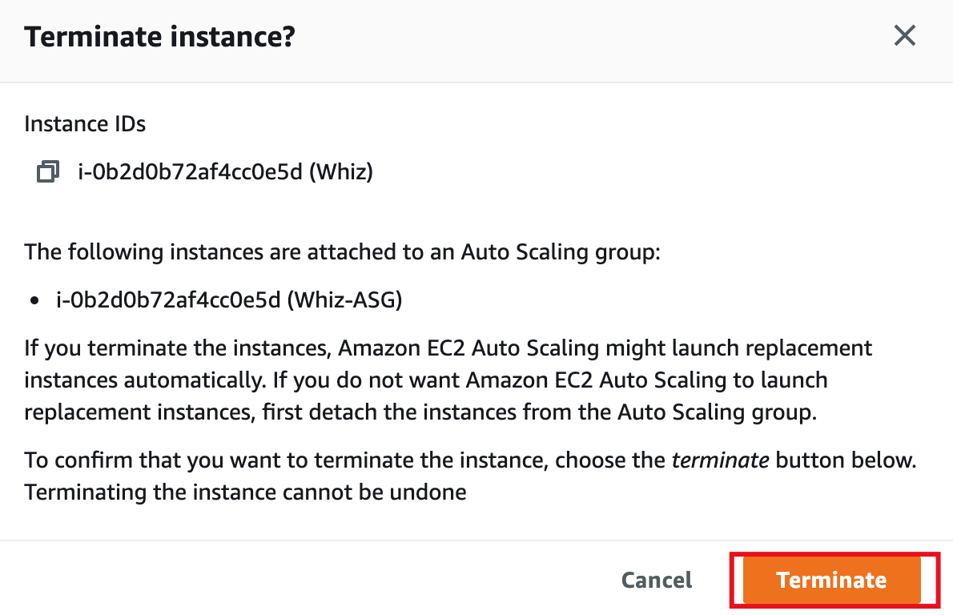
4. This will terminate your instance.  
   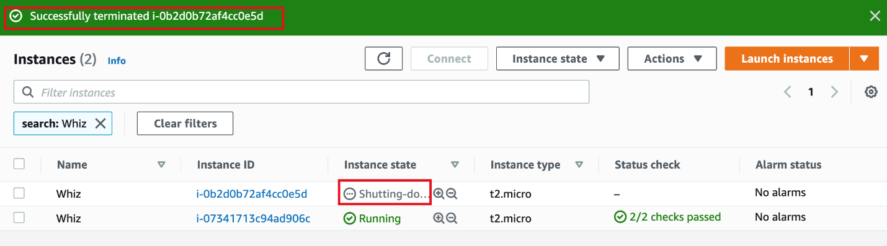
5. Once your instance is terminated. You can go to the **Auto scaling groups** page and see the **Instances is 1** and the **Status** is **Updating capacity**.  
   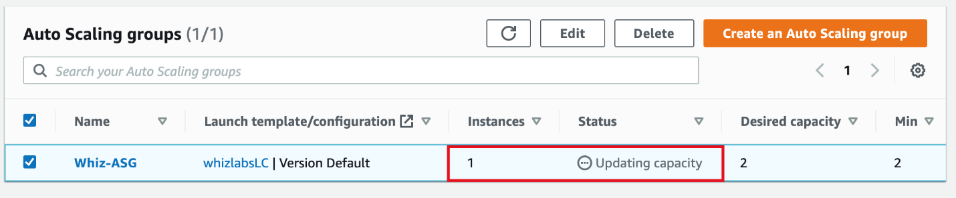
6. Alternatively, you can look for the **Activity history** under **Activity** of your Auto scaling group to see what happened.
7. Meanwhile, A new instance will be launched to fulfill the policy condition.  
   A sample screenshot is provided below:

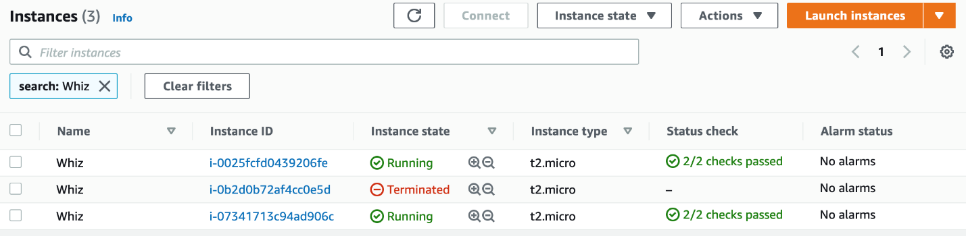

* **Note:**Launching a new instance may take up to 5 minutes, you can refresh the page to view the new instance.

Task 7: Validation Test

1. Once the lab steps are completed, please click on the  button on the left side panel.
2. This will validate the resources in the AWS account and displays whether you have completed this lab successfully or not.
3. Sample output :

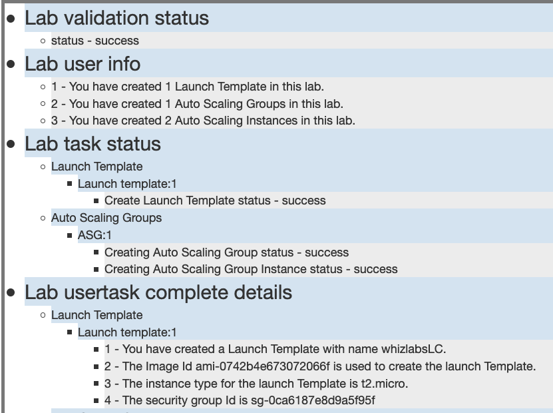

Task 8: Delete AWS Resources

Deleting Auto scaling group

1. In the EC2 console, navigate to **Auto scaling groups** in the left-side panel.
2. **Whiz-ASG** will be listed here.  
   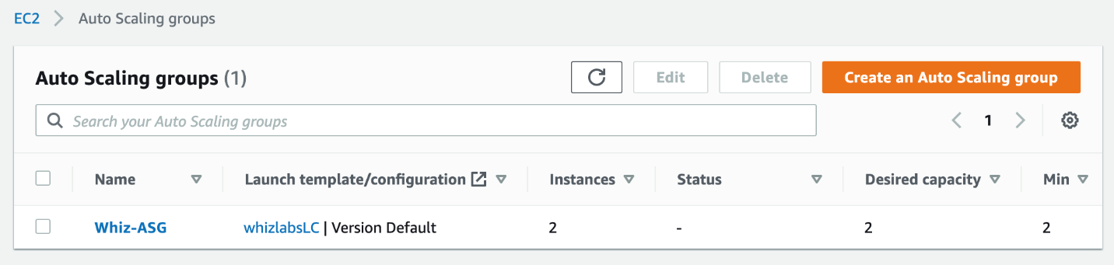
3. To **delete** the Auto scaling group, need to perform the following actions:
   * **Select** the auto scaling group, **Whiz-ASG**
   * Click on the **Delete** button,  
     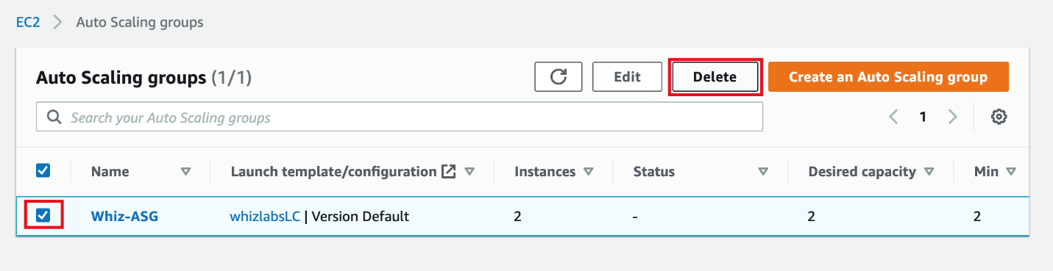
4. Confirm by entering **delete** and click on the **Delete** button when a pop-up is shown.  
   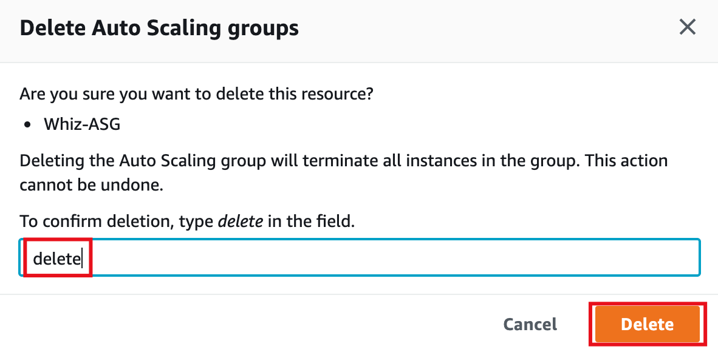
5. **Whiz-ASG's** status will be shown as Deleting immediately.  
   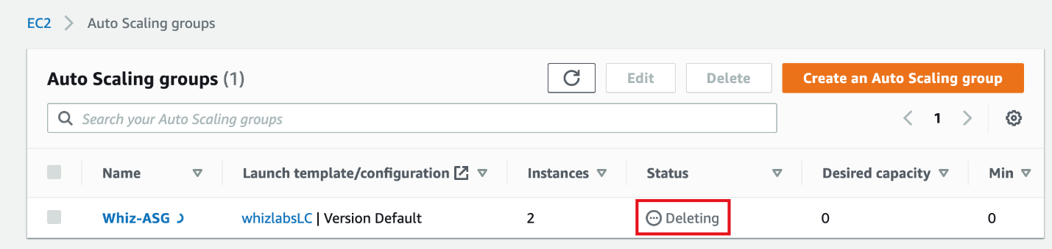
6. It can take up to 3 minutes to delete because it will terminate the EC2 instances.
7. You can confirm the termination of EC2 instances by visiting the **Instances** page.  
   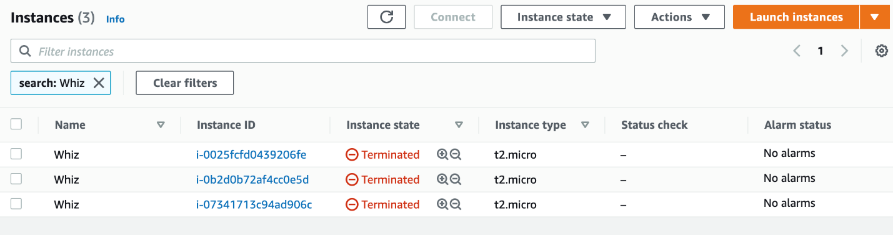

Deleting Launch templates

1. In the EC2 console, navigate to **Launch templates** in the left-side panel.
2. **WhizlabsLC** will be listed here.  
   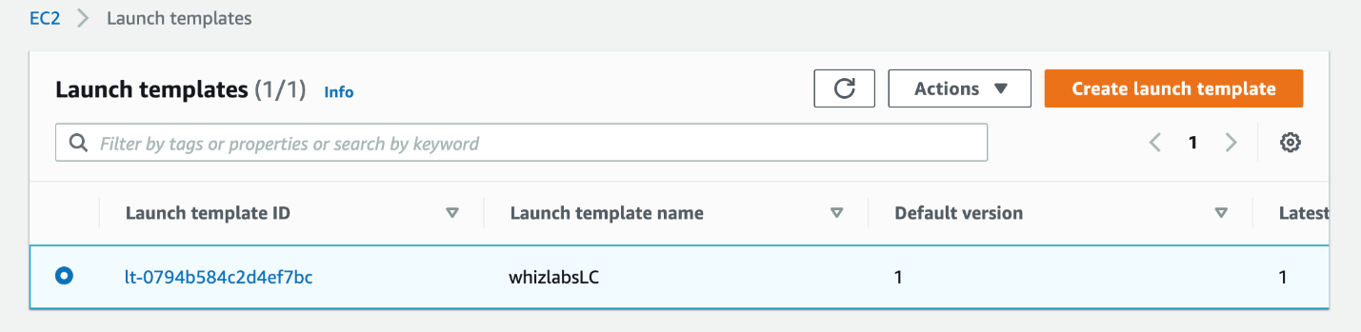
3. To delete the **Launch template**, need to perform the following actions:
   * **Select** the Launch template,
   * Click on the **Actions** button,
   * choose the **Delete template** option  
     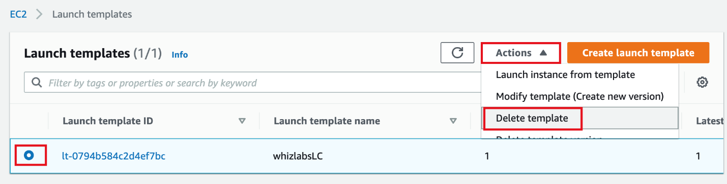
4. Confirm by **entering** **Delete** and clicking on the **Delete** button when a pop-up is shown.  
   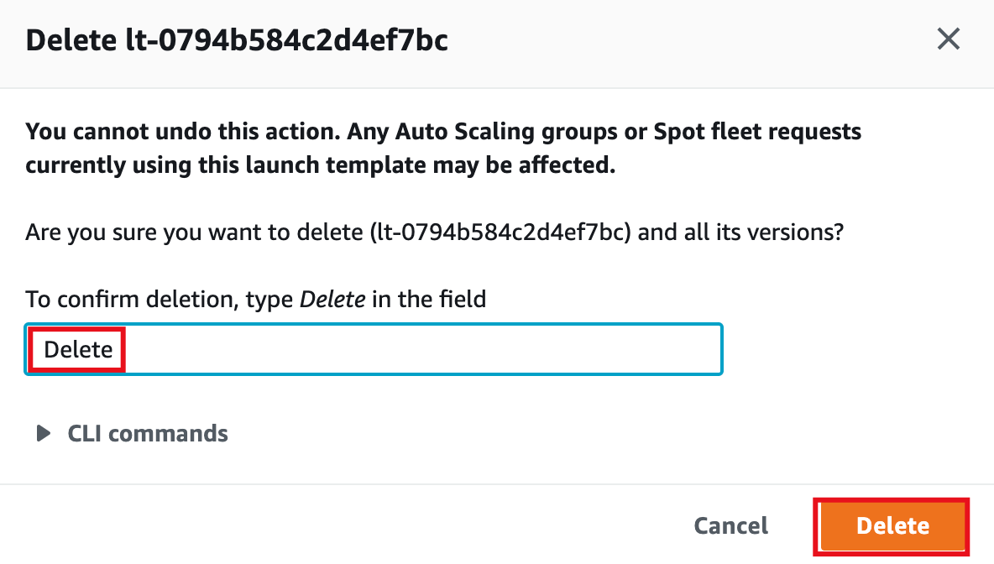
5. **Whiz-ASG**will be deleted immediately.

**Completion and Conclusion**

1. You have created a security group and key pair for the Launch template.
2. You created a **Launch template**and **Auto Scaling**.
3. You have launched two EC2 instances through Auto scaling.
4. You have tested the Auto scaling by terminating one of the instances manually.